**A Synopsis**

**on**

**[IT2510] Mini Project**

**Third Year I.T.**

“IoT BASED AUTOMATED LIGHT SYSTEM”

**Submitted By:**

## Omkar Dhage (20141204)

## Prathamesh Sabale(20141216)

**Under guidance of:**

## Prof. N.M.Mule



**Government College of Engineering,Karad. (An Autonomous Institute of Government of Maharashtra)**

**Department of Information Technology**

**Academic Year 202**1**-2**2**(Semester-V)**

# ABSTRACT

*-This project is all about the motion detection using Passive Infra-Red (PIR) sensor and light detection using a Light Dependent Resistor(LDR) sensor with Arduino, wirelessly. Besides that, it also acted as an auto power switching system. When the sensor is triggered, the signal will transmit wirelessly to take action. Relays manage small current that can control much larger current. When a small current flows through the first circuit, it activates the electromagnet, which generates a magnetic field all around it.* *The PIR sensors detect changes in amount of infrared radiations incident on it and then LDR sensor checks for the light present. Whenever any object like human being passes in front of the PIR sensor, the temperature of the area will change from the room temperature to body temperature. The temperature will be back again when the object has moved ahead. Arduino is coded to take the input from PIR and LDR, if it receives the high input then it activates the relay and the Light is Switched On. Before switching on it checks for both the conditions one of PIR and one of LDR. The Relay Module is a device that switches power to auxiliary devices.*

Automation in various daily used devices is becoming more and more popular and crucial these days. Automated lightening is a crucial part as it makes human life easy along with saving the wastage of electricity. Most lightening system available are expensive and complex also hard to install. Here is automated light system prototype is developed to replace the ordinary light switches. An easy to install, and automated system for saving the electricity was the ultimate goal of this project.

* An automatic control system will allow to control the illumination and it will decrease the energy costs.
* In an economy that is accepting the need for energy reduction due to the realisation of limited fossil fuels, it is important to maintain and enhance energy efficient systems.
* To get rid of traditional bulbs.
* An automated system to illuminate human interference.

.

Research highlighted that previous studies would either use PIR to detect change in temperature and then automatically glow a bulb or a LDR to detect the light and then if already present then it won’t glow and if dark the it would work, but never both. This thesis combined both of these approaches for automated light system which saves energy while ensuring that occupant’s satisfaction and comfort is maintained by illuminating manually switching switches by using relay modules instead.

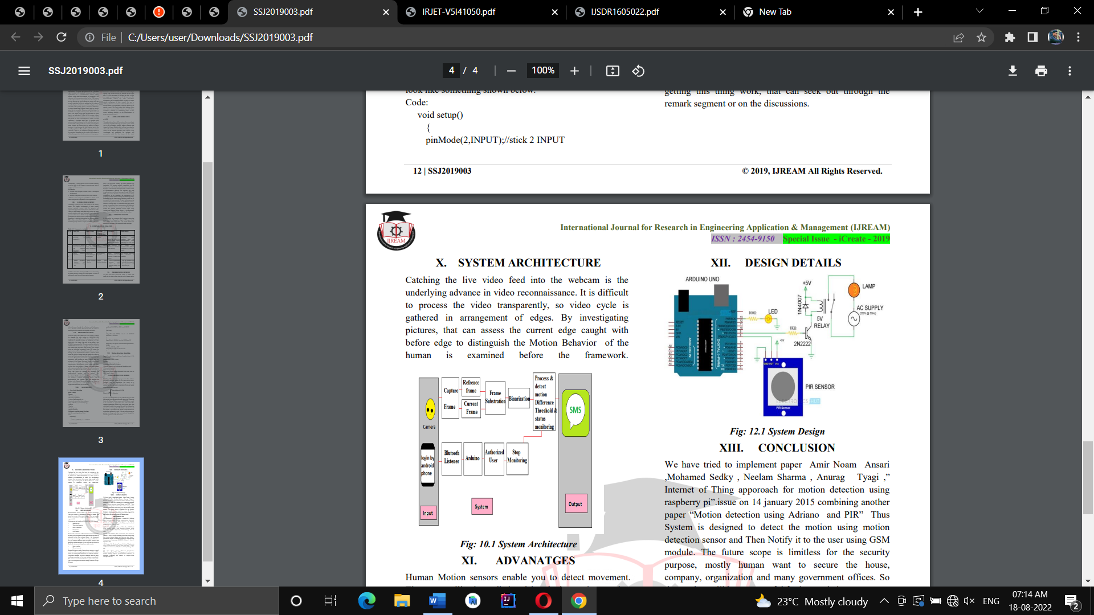Passive infrared (PIR) –

The most common motion sensor for residential properties, PIRs detect body heat, which alters infrared energy. When a sensor detects the slightest change in temperature within its protective grid, it signals an alarm. In the past, PIRs could be tripped by incoming sunbeams, but this issue has been rectified in newer infrared sensors. (The word “passive” in the term “passive infrared” refers to principle nature of sensor. Proximity sensors must generate their own infrared radiation actively, which is interrupted or reflected by nearby objects whereas PIR doesn’t need to generate or emit any type of radiation.)

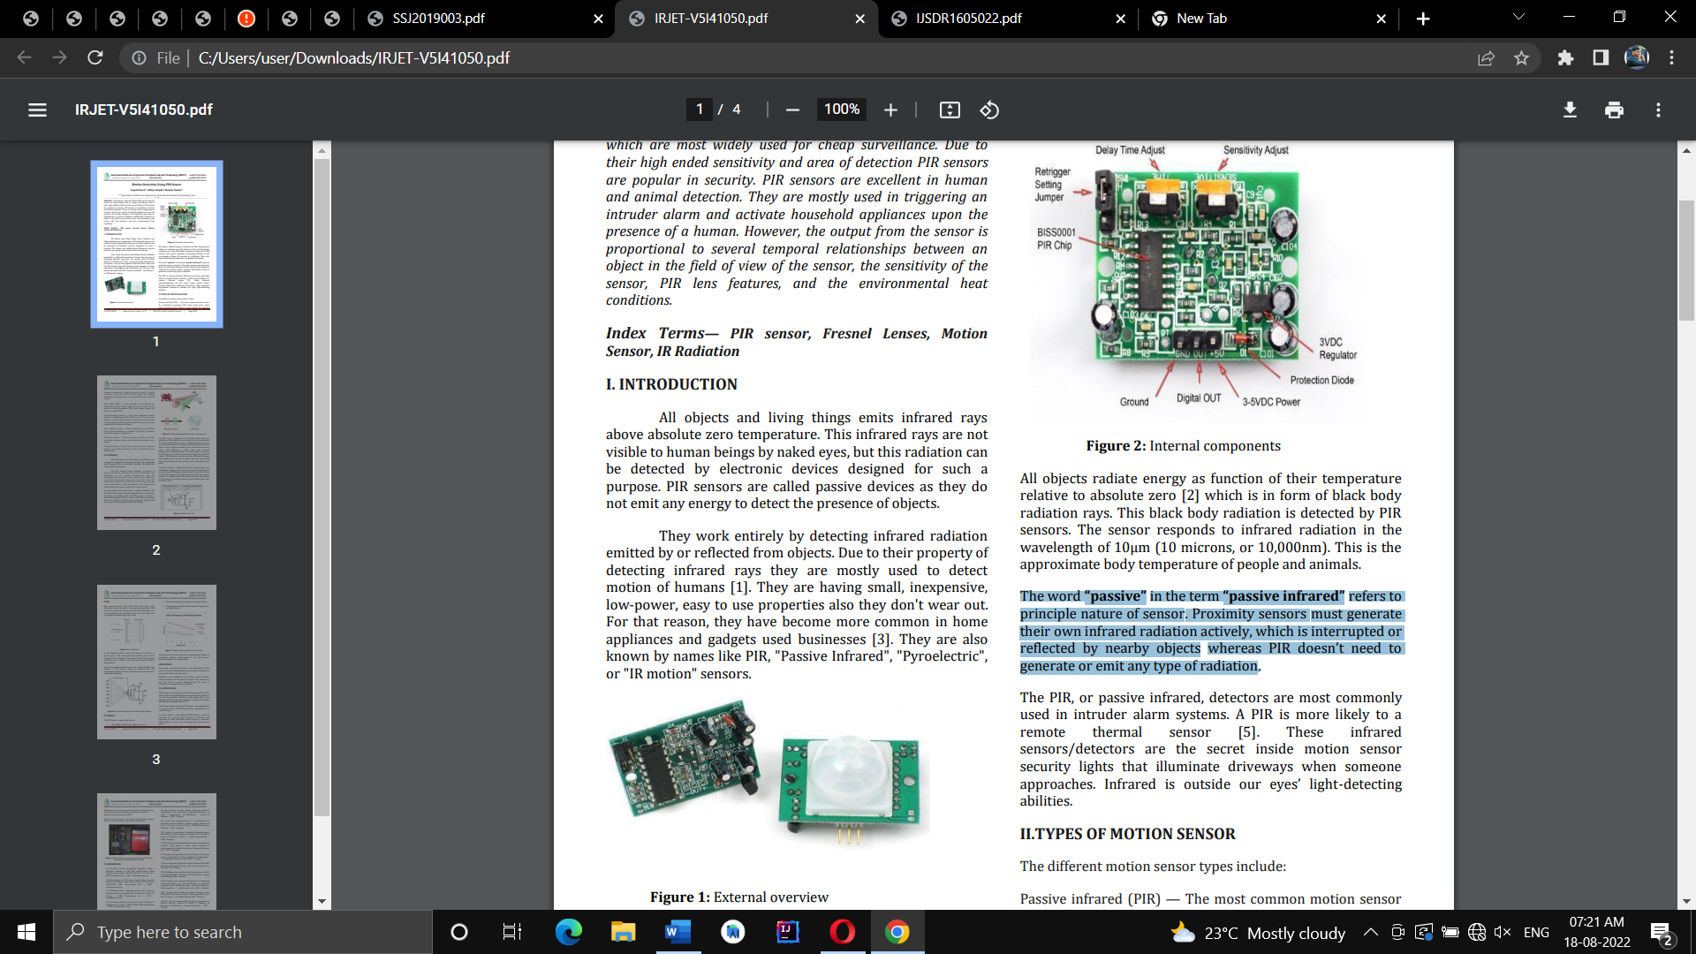



Output signal and heat source movements

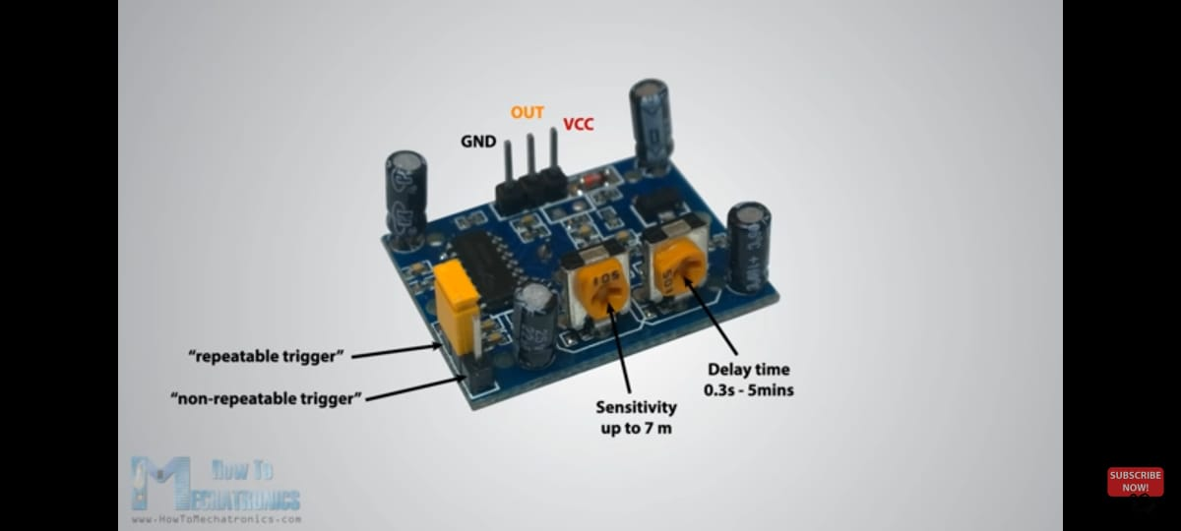

Arduino-

The Arduino UNO is a standard board of Arduino. Here UNO means 'one' in Italian. It was named as UNO to label the first release of Arduino Software. It was also the first USB board released by Arduino. It is considered as the powerful board used in various projects. Arduino.cc developed the Arduino UNO board.

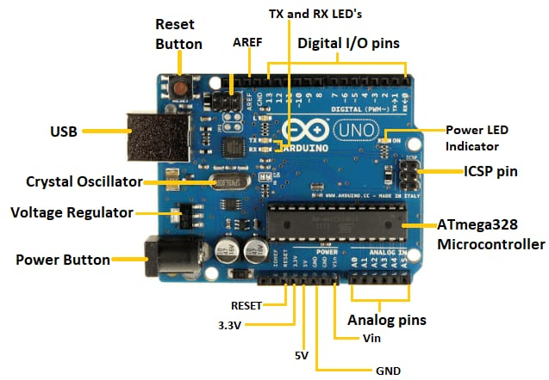

The Arduino UNO includes 6 analog pin inputs, 14 digital pins, a USB connector, a power jack, and an ICSP (In-Circuit Serial Programming) header. It is programmed based on IDE, which stands for Integrated Development Environment. It can run on both online and offline platforms.

ATmega328 Microcontroller- It is a single chip Microcontroller of the ATmel family. The processor code inside it is of 8-bit. It combines Memory (SRAM, EEPROM, and Flash), Analog to Digital Converter, SPI serial ports, I/O lines, registers, timer, external and internal interrupts, and oscillator.

ICSP pin - The In-Circuit Serial Programming pin allows the user to program using the firmware of the Arduino board.

Power LED Indicator- The ON status of LED shows the power is activated. When the power is OFF, the LED will not light up.

Digital I/O pins- The digital pins have the value HIGH or LOW. The pins numbered from D0 to D13 are digital pins.

TX and RX LED's- The successful flow of data is represented by the lighting of these LED's.

AREF- The Analog Reference (AREF) pin is used to feed a reference voltage to the Arduino UNO board from the external power supply.

Reset button- It is used to add a Reset button to the connection.

USB- It allows the board to connect to the computer. It is essential for the programming of the Arduino UNO board.

Crystal Oscillator- The Crystal oscillator has a frequency of 16MHz, which makes the Arduino UNO a powerful board.

Voltage Regulator- The voltage regulator converts the input voltage to 5V.

GND- Ground pins. The ground pin acts as a pin with zero voltage.

Vin- It is the input voltage.

Analog Pins- The pins numbered from A0 to A5 are analog pins. The function of Analog pins is to read the analog sensor used in the connection. It can also act as GPIO (General Purpose Input Output) pins.

Relay-

A relay is an electromagnetic switch operated by a relatively small current that can control much larger current. When a small current flows through the first circuit, it activates the electromagnet, which generates a magnetic field all around it.The energized electromagnet attracts a contact in the second circuit toward it, closing the switch and allowing a much bigger current to flow through the second circuit. When the current stops flowing, the contact goes back up to its original position, switching the second circuit off again.

The dual-channel relay module is more or less the same as a single-channel relay module, but with some extra features like optical isolation. The dual-channel relay module can be used to switch mains powered loads from the pins of a microcontroller. This module is designed for switching two high powered devices from your Arduino. It has two relays rated up to 10A per channel at 250VAC or 30VDC. There are two LEDs on the relay module indicating the position of the relay. Whenever a relay is activated, the respective LED will light up.One of the best things about these modules is that they come with two Optocoupler ICs which provide good isolation between relay and Arduino.

Developing **“IOT based Automated Light System”** was the problem statement for the project .In the project we aimed in building such a system which would sense the human interference in the installed region and also check for the presence of light and if it satisfies the given condition it will glow the bulb automatically without human interference.

This elaborates the design and construction of automatic light control system circuit. Circuit works properly to turn lamp ON/OFF. PIR and LDR sensors are the main conditions in working the circuit. If the conditions have been satisfied the circuit will do the desired work according to specific program. Each sensor controls the turning ON or OFF the lighting column. Here when both the conditions on two different systems are satisfied then the system works. The lights has been successfully controlled by Arduino.

Here Fully Automated System with no man power required system is built.Also the Goal of Saving Wastage Of Electricity has been achieved.The system is Cost Effective Over Other Existing Systems and Minimum Installation Cost was required.

1. .Prof.Akshay Agrawal, Mr.Mahesh Kshirsagar, Mr.Vivek Yadav, Miss.Rupali Ghodvinde ,“**Motion Detection Using Arduino”** International Journal for Research in Engineering Application & Management (IJREAM) 2019 Edition
2. Yogesh Pawar,Abhay Chopde, Mandar Nandre,” **Motion Detection Using PIR Sensor**”, International Research Journal of Engineering and Technology (IRJET) Volume: 05 Issue: 04 | Apr-2018
3. Ajay Kumar Tiwari,Prince Raj, “**MOTION DETECTION USING PIR SENSOR** International Journal of Scientific Development and Research (IJSDR) May 2016 Volume 1 Issue 5
4. Siti Nurmani, Bambang Tukuto, SarifaPutri Raflesia**,** “ **Real-Time Lighting Control System for Smart Home Applications**”  Computer Engineering and Applications Journal · October 2018.
5. Muhammad M. A. S. Mahmoud, “**Automated Smart Utilization of Background Lights and Daylight for Green Building Efficient and Economic Indoor Lighting Intensity Control”,** Intelligent Control and Automation Journal, 2021
6. Feng, X Guo, G Wang “**Infrared motion sensing system for human-following robots G - Sensors and Actuators**”, A: Physical, 2012 – Elsevier
7. Q Cao, T Yan, J Stankovic, T Abdelzaher, “**Analysis of target detection performance for wireless sensor networks”** - … Computing in Sensor Systems, 2005 - Springer
8. A great page on PIR sensors from GLOLAB
9. S Lee, KN Ha, KC Lee **“A pyroelectric infrared sensor-based indoor location aware system for the smart home”** - IEEE Transactions on Consumer …, 2006 - ieeexplore.ieee.org
10. R. Piyare and M. Tazil, “**Bluetooth Based Home Automation System**

**Using Cell phone",** in IEEE 15th International Symposium on Consumer

Electronics, Singapore 2011

10.Arduino PIR Sensor Integration by MehMet AVCU.

11.Sensors And Transducers by D.Patranabis.